SECURE DATA TRANSMISSION IN CLOUD COMPUTING USING ENCRYPTION AND MACHINE LEARNING
Scope and Limitations
Department of Computer Science and Engineering, TKR College of Engineering & Technology
Batch A5 (CSE-A) · Academic year [ACADEMIC YEAR]
Table 1: Project team
S.No. | Student name | Roll number
1 | Avuti Sandhya | 23K91A0520
2 | Banothu Indu | 23K91A0530
3 | Dasari Sriteja | 23K91A0559
4 | Bejugam Vaishnavi | 23K91A0533

Project guide: CH. Prabhakar
Chapter and section numbers quoted in the text (for example Chapter 8 or Section 6.2) refer to the full project report, 17.Final Document. Figures and tables in this document are numbered from 1.

1. SCOPE

1.1 What is in scope
• Encrypting text (up to 1 MB) and files (up to 5 MB) before they reach a mock cloud endpoint, and decrypting and verifying them there.
• Scoring single flow records and CSV batches (up to 10 MB and 10,000 rows) in the 42-feature UNSW-NB15 schema as normal or attack, with confidence and severity.
• An in-memory alert log of up to 500 attack verdicts, an API, a React console and the original HTML dashboard.
• Offline training of the detector on synthetic data (shipped default) or on real UNSW-NB15 CSV/parquet files, and serving of a chosen model bundle.
• Measurements of detection quality, cryptographic cost and combined overhead on one machine.

1.2 What is out of scope
Table 2: Items deliberately not covered
Item | Why it is out | Where it appears
Live packet capture and flow export | Needs privileged network access and a flow exporter; flows are supplied as records or CSV rows | Future scope
Blocking or quarantining a flagged session | The API does not gate a transfer on the verdict; the operator decides | Future scope
A real cloud provider, upload and download | The cloud is a mock endpoint with a process-lifetime key pair | Future scope
Key custody (KMS, HSM), certificates, key rotation | Keys exist only in memory | Future scope
Authentication, TLS, rate limiting | Local demonstration service bound to 127.0.0.1 | Future scope
Persistent storage of alerts | The alert list is lost on restart | Future scope
The base paper's EECC and quantum-inspired network | Not reproduced; standard primitives and models were used | Chapter 8, Section 8.8
Adversarial and evasion testing of the detector | Not attempted | Limitations
Load, concurrency and multi-tenant testing | Single-user measurements only | Limitations

2. ASSUMPTIONS
The results and the design rest on the following assumptions.
• The 42 UNSW-NB15 flow features describe the traffic well enough to separate attacks from normal flows; this holds on the benchmark but is not established for other networks.
• Labels in UNSW-NB15 are correct and its official training and testing sets are a fair stand-in for 'the past' and 'the future'.
• The mock cloud's key pair, which lives in process memory, stands for a long-term cloud key held securely elsewhere.
• The cryptography library and the operating system's random number generator are trustworthy; no side-channel or implementation attack is considered.
• Operators accept a threshold of 0.5 unless they choose another; the product does not tune it.
• The service is run locally (127.0.0.1) by a trusted operator; there is no hostile client.

3. LIMITATIONS

Data and model limitations
• The default model is trained on synthetic data. Its 0.9733 accuracy is a property of the generator (2.5% label noise, near-perfect separability) and drops to 0.660 on real flows (ROC-AUC 0.657).
• The official UNSW-NB15 test set is temporally shifted and harder than a random split. The stacked model reaches 0.890 ± 0.002 there, but a 22.6% false-alarm rate on normal flows at threshold 0.5.
• Stacking did not beat XGBoost. XGBoost alone scores 0.910 ± 0.001; the CNN adds false alarms and 246 s of CPU training time.
• Fuzzers are missed 13.3% of the time, and a single feature, sttl, dominates the importance ranking, a known artefact of the UNSW-NB15 testbed.
• The CNN is trained with an unweighted binary cross-entropy loss in the PyTorch branch that ran, although the README describes balanced weighting (which exists only in the TensorFlow branch).
• Missing features default silently to average values at the API, so a partial record can look benign.

Security and system limitations
• Mock cloud with an in-memory key pair. There is no key storage, rotation or certificate, so objective 2 (key storage) is not met.
• Demo shortcut in decryption. The API caches session keys by ephemeral public key; any caller who knows an ephemeral public key can ask for decryption. The real ECDH path (cloud private key) is used when the cache misses and is tested, but the cache is not a production design.
• No authentication, TLS or rate limiting; CORS allows every origin.
• The alert list is in memory (at most 500 entries) and is lost on restart; there is no database.
• No live traffic. The system scores supplied records; it does not capture packets and does not tie a verdict to a particular transfer.
• Resource limits are fixed in code: 1 MB text, 5 MB file, 10 MB or 10,000-row CSV.

Evaluation limitations
• One public data set from one laboratory; one machine; no significance tests; timings on a shared desktop CPU.
• The comparison with the base paper is indicative: its subset, hyper-parameters and test fraction are not published.
• The Docker image, the TensorFlow code path and browsers other than Chrome were not tested.
Two figures show the limitation that matters most for reading the numbers. The first shows where the training data comes from decides everything: the shipped model is excellent on its own synthetic data and close to chance on real traffic. The second shows which traffic categories the real-trained model handles well and where it does not.
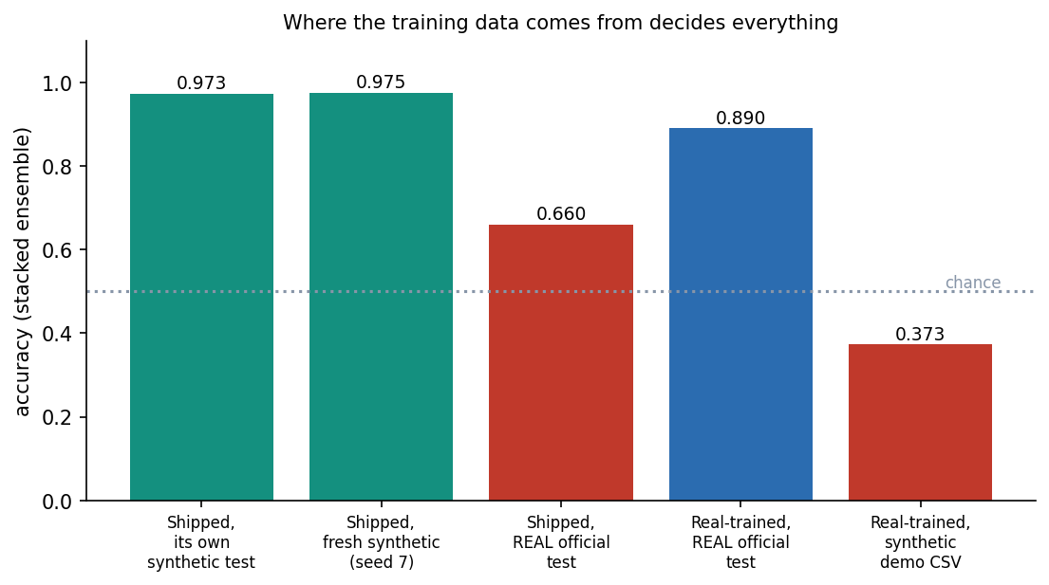
Figure 1: Accuracy of the stacked ensemble by training data and test data: synthetic-trained models do not transfer to real UNSW-NB15 flows.
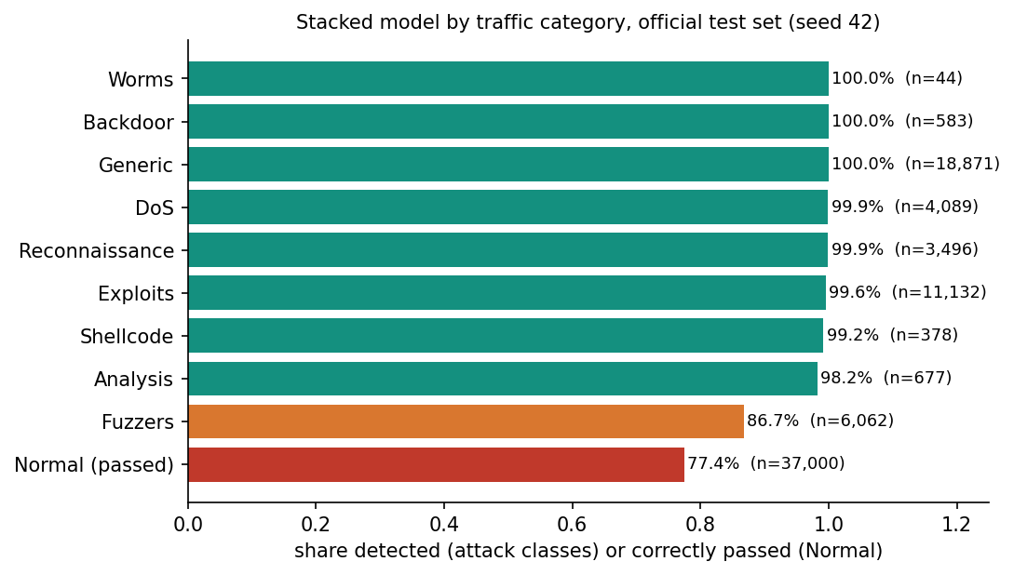
Figure 2: Share of each traffic category handled correctly by the real-trained stacked model on the official test set.

4. WHAT WAS NOT MEASURED
The following were not measured and are therefore stated as gaps, not as results.
• Network latency to a real cloud provider, TLS overhead and behaviour under concurrent users.
• Memory footprint and energy use of the detector and of SecureChannel.
• Robustness of the detector against adversarial or evasive traffic, and its behaviour on traffic from another network or another benchmark.
• Security of the base paper's EECC and the accuracy of its quantum-inspired network (neither implemented).
• Detection accuracy on live captured traffic; the system has only scored supplied records.
• A statistical significance test between the stacked model and XGBoost; the seed spread suggests the gap on the official partition is stable, but no test was run.
• RSA hybrid encryption inside the product; it exists only in the benchmark script.
• The Docker deployment and the original run.bat installation path on a clean machine.

